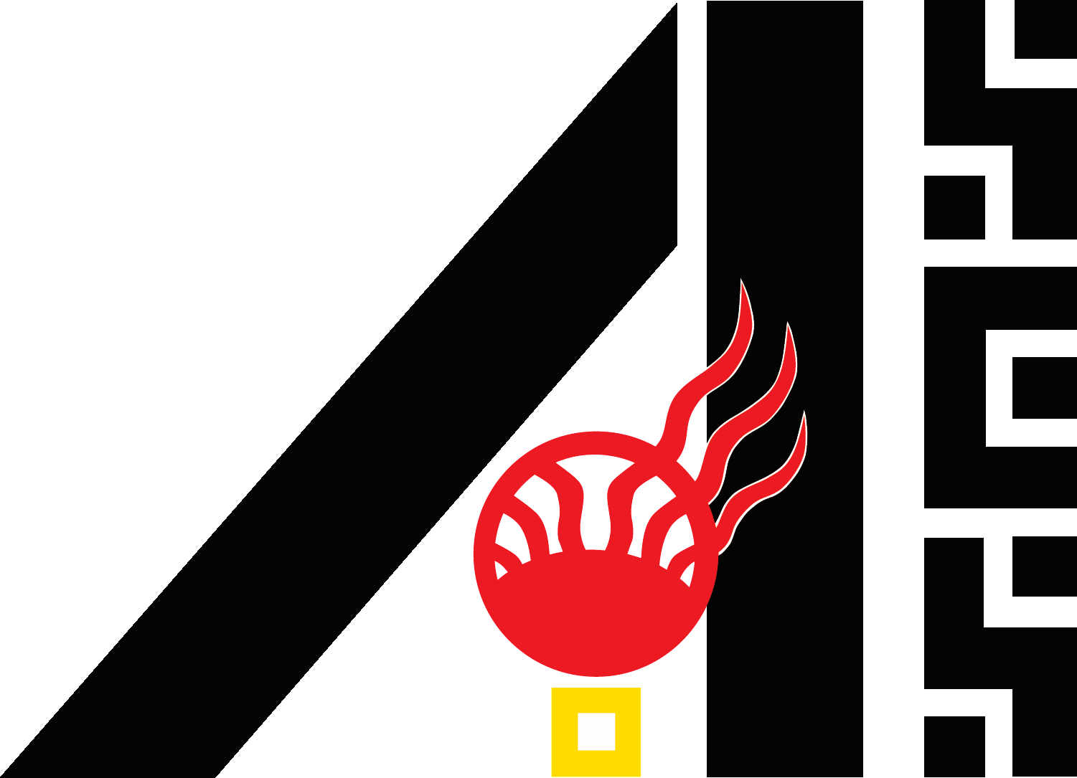
National American Indian Science and Engineering Fair
STUDENT/PARENT LIABILITY AND MEDIA RELEASE FORM

The student, sponsoring teacher, and parent/guardian hereby agree that they accept the following conditions:

1) I shall abide by ALL fair rules and procedures (regional, state, and Intel ISEF) or risk disqualification.
2) I understand that sponsors, officials, & volunteers of the Fair are not responsible for loss/damage, or failed uploads of materials to the project. It is recommended that each student take prudent precautions to prevent any theft, loss, or damage to his/her materials and to protect the copyrights, if any, of their material.
4) I will make backup copies of all materials, forms, documents submitted.
5) I agree that should my entered project win in its category, that my video and slideshow may be displayed on the AISES website for one year.
6) I (the teacher) agree to sponsor the student and assume responsibility for compliance with ALL existing Intel ISEF rules for the current year.
7) I (the teacher) agree to conduct a safety review of the project.
8) I understand that the decision of Fair officials is final in the selection of winners. I shall not be entitled to the contact information of Fair Officials nor shall I attempt to contact any Fair officials concerning selection of winners. The term “Fair officials includes but is not limited to any and all judges involved in the selection of winners.
9) I understand that any opinions expressed by judges and/or award donors are solely those of that individual or organization and do not represent the opinions of AISES.
10) I give permission to use appropriate information about me for public purposes (including photos, videos, or likenesses that may be used by each Fair/Challenge or sponsors of awards) for the purposes of illustrations, advertising, or publication in any manner. I also consent to use of my name therewith. No personal identifying information will be made public such as address or birthdates, etc.

The AISES NAISEF is a prestigious event and your participation is newsworthy. The organizations and/or businesses sponsoring awards at the fairs may want to publicize their involvement in such an important science competition by
using photographs/information about you. Your cooperation will help make it possible for other promising young students to get involved in research.

□ By checking this box, I give NAISEF permission to share my contact information with universities and/or colleges

____________________________________________ _____________________________________________
Teacher/Sponsor (Circle One) Name Printed Teacher/Sponsor Signature

__________________________________ ________________________________ ______________________________
Student Name Printed Student 2 Name (if a team) Printed Student 3 Name (if a team) Printed

__________________________________ ________________________________ ______________________________
Student Signature Student 2 Signature Student 3 Signature

__________________________________ ________________________________ ______________________________
Parent/Guardian Name Printed Parent/Guardian of Student 2 Printed Parent/Guardian Student 3 Printed

__________________________________ ________________________________ ______________________________
Parent/Guardian Signature Parent/Guardian of Student 2 Signature Parent/Guardian Student 3 Signature
AISES MISSION STATEMENT:
The American Indian Science and Engineering Society (AISES) is a national, nonprofit organization focused on substantially increasing the representation of American Indians, Alaska Natives, Native Hawaiians, Pacific Islanders, First Nations and other indigenous peoples of North America in science, technology, engineering and math (STEM) studies and careers.

